Methodology
Multi-Location Temporal Forecasting of Near-Surface Temperature and Relative Humidity Across Diverse Climatic Regions of India Using a Stacked Ensemble Framework

1. Research Design and Justification
This study adopts a quantitative, empirical, and comparative predictive-modelling design, situated within the broader methodological tradition of applied time-series machine learning for environmental forecasting. The research question — whether a stacked ensemble of gradient-boosted learners can outperform classical statistical and deep-learning baselines in forecasting near-surface temperature and relative humidity across a climatically heterogeneous national territory — necessitates a design capable of isolating three distinct sources of predictive difficulty: temporal dependence within a single location's series, structural differences between competing modelling paradigms, and spatial generalisation across locations with materially different climatic regimes. The design adopted here addresses each of these in turn.

1.1 Comparative Multi-Model Rationale
Rather than reporting the performance of the proposed ensemble in isolation, four forecasting paradigms are evaluated under identical conditions: a naïve persistence baseline, a classical autoregressive statistical model (ARIMA), a deep sequence-learning model (LSTM), and the proposed stacked ensemble. This triangulation is methodologically necessary rather than merely conventional. The persistence baseline quantifies the proportion of apparent predictive skill attributable to short-horizon autocorrelation inherent to hourly meteorological data — a quantity that must be established before any more complex model's performance can be meaningfully interpreted. ARIMA represents the classical statistical benchmark against which the incremental value of machine-learning approaches is conventionally assessed in the forecasting literature. The LSTM represents an alternative, structurally distinct machine-learning paradigm (sequential deep learning) against which the tree-based ensemble's relative merit can be established. Without all four, a reported skill metric for the proposed model is uninterpretable in isolation; comparative design converts a single number into an evidenced claim.

1.2 Multi-Location Design Rationale
India spans multiple Köppen climate classifications — semi-arid, tropical wet, tropical wet-and-dry, humid subtropical, and montane regimes among them — within a single national boundary. A model trained and evaluated on a single city, or on a randomly pooled sample that does not respect city boundaries, cannot support a claim of general applicability across this heterogeneity. The study therefore adopts a multi-location design operating at two nested scales: the full-dataset scale (approximately 550 locations) is used for model training and for the spatial-generalisation tests described in Section 6.3, while eight cities spanning the country's principal climatic zones (Delhi, Mumbai, Chennai, Kolkata, Bengaluru, Hyderabad, Ahmedabad, and Pune) are designated as the primary study cities for descriptive exploratory analysis and illustrative reporting.
Reviewer Comment 11 — The reviewer identified a multi-step forecast figure generated for a city (Adilabad) that was not among the eight cities defined as the study's illustrative scope. This has been resolved structurally, not merely editorially: the eight study cities are enforced in code as a single-source-of-truth allow-list, and any function generating a per-city illustrative figure refuses to execute for a city outside this list, making a recurrence of this specific error structurally prevented rather than dependent on manual checking.:

1.3 Time-Series-Aware Validation Rationale
A substantial methodological risk in applied time-series machine learning is the inadvertent use of validation procedures developed for independently and identically distributed data — random k-fold cross-validation being the principal example — which permit information from temporally future observations to inform predictions of temporally past observations within the same fold. Such leakage inflates reported performance in a manner that does not generalise to genuine forecasting deployment, where only past data is ever available. Accordingly, every validation procedure in this study (chronological train/test split, walk-forward rolling-origin validation, and the internal stacking meta-learner's own cross-validation) is constructed so that no model, at any stage, is permitted to learn from an observation that is temporally later than any observation it is subsequently evaluated against. This constraint is treated as a non-negotiable design requirement rather than a refinement, and its violation in an earlier iteration of the modelling pipeline — and the corresponding structural correction — is documented explicitly in Section 6.4.4.

1.4 Spatial Generalisation Rationale
A model that performs well when trained and tested on the same set of locations, differing only in time, answers a materially different question from a model asked to forecast for a location it has never observed. Because a central claim of this study concerns applicability across India's climatic diversity, a leave-one-city-out (LOCO) validation protocol (Section 6.3) is incorporated as a first-class element of the research design, not an auxiliary robustness check. City identity is deliberately withheld from the model during this procedure, since a genuinely unseen deployment location would not possess a value for a city-identity feature learned during training.

2. Data Collection

2.1 Data Source
The study draws on the Indian Weather Repository, a secondary, publicly available, hourly-updated meteorological dataset aggregating near-surface observations across several hundred Indian locations. As a continuously updating (“live”) source, the dataset does not possess a fixed, immutable version by default; this study therefore treats dataset versioning as a first-order data-collection concern rather than an afterthought (Section 5.4).

2.2 Variables Collected
The variables retained for analysis, and the rationale for their inclusion, are as follows:
- Near-surface air temperature (°C) and relative humidity (%) — the two target variables, selected as the primary atmospheric quantities of practical forecasting relevance for agricultural planning, public health advisories, and energy demand estimation.
- Location identifier and administrative region — retained to support the multi-location design (Section 1.2) and to construct region-level categorical context.
- Observation timestamp — retained at native (hourly) resolution to support lagged and cyclical temporal feature construction (Section 4.4).
- Qualitative weather condition descriptor — retained as a categorical contextual feature capturing synoptic state (e.g., clear, overcast, precipitating) not fully reducible to the two continuous targets.
Auxiliary fields present in the raw export (e.g., wind speed, atmospheric pressure) were not included as predictors in the present modelling scope; their omission reflects a deliberate scope decision to isolate the temporal and spatial forecasting problem rather than a data availability limitation, and is noted here as a candidate direction for future extension.

2.3 Secondary-Data and Ethical Considerations
The dataset comprises publicly released, non-personal, station-level meteorological observations and contains no personally identifiable information. As a secondary dataset, no primary data collection instrument, consent procedure, or institutional ethics review was required for its use in this study.

2.4 Data Volume and Structure
At the time of analysis the cleaned dataset comprised observations for approximately 550 distinct locations at hourly resolution, yielding a pooled dataset on the order of tens of thousands of city-hour records after the cleaning procedures described in Section 3 were applied. Because the source updates continuously, exact record counts are run-dependent; the dataset hash and date reported in Section 2.5 anchor each reported result to a specific, reproducible snapshot.

2.5 Dataset Provenance and Versioning
To address the reproducibility risk inherent to a live data source, every analytical run computes and reports a SHA-256 cryptographic hash of the exact CSV file used, together with either the true acquisition date (where supplied) or the file's last-modified timestamp, explicitly labelled as a proxy where the true acquisition date is unavailable. This directly satisfies the requirement, raised during peer review, that a live dataset be anchored to an identifiable, citable snapshot rather than referenced as an undated, continuously moving target.
Reviewer Comment 9 — The reviewer noted that the dataset source is described as “Live” and therefore lacks a fixed, citable version. Runtime computation and reporting of a SHA-256 file hash and acquisition date (Section 2.5) resolves this by anchoring every reported result to an identifiable, reproducible snapshot rather than an undated moving target.:

3. Data Preprocessing

3.1 Schema Standardisation
Because dataset exports of this kind are not guaranteed to preserve fixed column names across snapshots or distribution mirrors, a column-resolution procedure matches each required semantic field — location identifier, administrative region, timestamp, temperature, humidity, and weather condition — against a prioritised list of plausible source-column names, adopting the first match found and logging the resolved mapping for full auditability. This step converts an otherwise brittle, hard-coded column mapping into a self-documenting and self-verifying one.

3.2 Temporal Parsing and Validation
Observation timestamps are parsed under a flexible scheme that accommodates either a Unix epoch integer representation or a human-readable date-string representation, falling back to a general-purpose parser where a fixed format fails to resolve a majority of records. The resulting parse success rate is computed and logged; a run in which fewer than half of all records yield a valid timestamp is halted with an explicit diagnostic error rather than permitted to proceed silently. This safeguard was introduced following an earlier pipeline iteration in which a non-temporal numeric field was inadvertently treated as the timestamp source, producing a completely empty analytical dataset without any visible failure — a class of silent data-corruption error that this validation step is designed to make structurally impossible to repeat.
Note: This correction was identified through internal quality-assurance testing during pipeline development rather than a numbered peer-review comment; it is documented here because it materially affects the trustworthiness of every downstream result and is directly relevant to the reproducibility standard raised in Reviewer Comment 8/9.

3.3 Cleaning and Type Coercion
Temperature and humidity fields are coerced to numeric type; records with missing temperature, humidity, timestamp, location, or region values are removed listwise. The resulting frame is sorted by location and then chronologically within location, establishing the strict temporal ordering required for all subsequent lag-based feature construction and time-aware validation.

3.4 Feature Engineering
The predictor feature set is constructed per location as follows, with each feature's inclusion justified on physical or statistical grounds rather than adopted by convention:
- Autoregressive lag features (temp_lag1, hum_lag1): the immediately preceding hourly observation of each target variable, motivated by the strong short-horizon autocorrelation characteristic of near-surface meteorological variables and directly substantiated by the correlation analysis reported in Section 4.
- Cyclical temporal encodings (hour_sin/hour_cos, month_sin/month_cos): sine–cosine transforms of hour-of-day and month, which preserve the circular adjacency of temporally adjacent periods (e.g., hour 23 and hour 0) that a raw integer or one-hot encoding would misrepresent as maximally distant.
- Categorical encodings (city_enc, region_enc, condition_enc): integer-encoded representations of location, region, and qualitative condition, applied for full-dataset model training and deployment. city_enc is deliberately withheld during the leave-one-city-out procedure (Section 6.3), since an unseen deployment location, by definition, has no learned encoding available at inference time — a distinction of direct methodological consequence that is made explicit rather than left implicit.
Reviewer Comment 2 — The reviewer requested explicit clarification of how an unseen city is encoded at test time during spatial-generalisation evaluation. The design decision to withhold city_enc specifically for the leave-one-city-out protocol (elaborated fully in Section 6.3) is stated here at the point the feature is first introduced, rather than left for the reader to infer downstream.:

3.5 Train/Test Partitioning
The primary evaluation partition is a chronological 75:25 split applied to the pooled, time-ordered dataset: the earliest 75 per cent of observations constitute the training set, and the most recent 25 per cent constitute the held-out test set. A random row-wise partition was deliberately rejected in favour of this chronological scheme, since randomisation across time would permit the model to be evaluated on observations temporally interleaved with its training data — a form of look-ahead leakage inconsistent with the deployment condition the model is intended to approximate, namely forecasting genuinely future, as-yet-unobserved conditions.

4. Exploratory Data Analysis
Exploratory analysis precedes model specification and serves a confirmatory, not merely descriptive, function: it substantiates the feature-engineering decisions of Section 3.4 and characterises the distributional properties that subsequent modelling and evaluation choices (Section 7) must accommodate. All figures are rendered at publication resolution (300 DPI).
Figure A. Density distributions of temperature and relative humidity across the full dataset, with mean and median markers, characterising the marginal distribution of each target variable.
Figure B. Boxplots of temperature and humidity across the eight study cities, evidencing the inter-city climatic heterogeneity motivating the multi-location design (Section 1.2).
Figure C. Diurnal (24-hour) profiles of hourly-mean temperature and humidity per study city, characterising the daily cycle each city-level model must capture.
Figure D. Representative raw time-series traces across a sample of cities, providing direct visual evidence of series length, seasonality, and noise characteristics.
Figure E. Correlation heatmap among the target variables and engineered features, empirically substantiating the inclusion of first-order lag features as dominant predictors (Section 3.4).

5. Modelling Framework
Four forecasting approaches are evaluated under identical test conditions — the same held-out period, the same locations, and the same physical units (°C for temperature, % for relative humidity) throughout — consistent with the comparative design rationale established in Section 1.1.

5.1 Persistence Baseline
The persistence forecast, ŷt+1 = yt, is evaluated on the identical held-out test set as every other model. As established in Section 1.1, this baseline is not a formality: it directly quantifies the extent to which any more sophisticated model's apparent skill is attributable to short-term autocorrelation already present in the raw signal, a quantity that must be established before the incremental contribution of any subsequent model can be meaningfully interpreted.
Reviewer Comment 3 — The reviewer noted the absence of a persistence baseline, prompted by the authors' own finding that lagged temperature dominates the proposed model's feature importance — raising the question of how much of its skill exceeds naïve persistence. This baseline is now computed under identical test conditions to every other model (Section 8.3), directly answering that question rather than leaving it inferred.:

5.2 ARIMA
An ARIMA model is fitted independently per location. Order selection follows a documented per-location grid search over p ∈ {0,1,2}, d ∈ {0,1}, q ∈ {0,1,2} (eighteen candidate specifications), retaining the order minimising the Akaike Information Criterion (AIC) on that location's training series, in preference to an unjustified fixed order. Forecasting proceeds via a rolling one-step-ahead procedure, in which the model is re-estimated after each newly observed test-period value is appended to its history, and is evaluated across each location's complete test window rather than a truncated subsample — ensuring the classical statistical baseline is assessed under conditions identical in scope to the proposed model.
Reviewer Comment 6 — The reviewer observed that the ARIMA baseline had previously been evaluated on only the first 100 test samples — a materially smaller evaluation scope than the proposed model's full 25% held-out test set — and that the ARIMA order (p,d,q) had been fixed without justification. Both are resolved here: ARIMA is now evaluated across each location's complete test window, and its order is selected per location via a documented AIC-minimising grid search rather than an unexplained fixed specification.:

5.3 LSTM
A sequence-to-value Long Short-Term Memory (LSTM) network is trained on the same chronologically partitioned data. The architecture comprises three stacked LSTM layers (128, 64, and 32 units respectively, ReLU activation) with batch normalisation and dropout (0.3, 0.3, 0.2) following each recurrent layer, a dense layer of 16 ReLU units, and a two-unit linear output layer predicting temperature and humidity jointly. Training employs the Adam optimiser (learning rate 0.001) for up to 100 epochs with a batch size of 64, subject to early stopping (patience 10, restoring best weights) and learning-rate reduction on plateau (factor 0.5, patience 5). The input window spans 24 hourly timesteps, and the validation partition comprises the chronologically final 20 per cent of training sequences — preserving, consistent with Section 1.3, the temporal ordering constraint throughout model development, not solely at the outer train/test boundary.
Reviewer Comment 6 — The reviewer noted that the LSTM baseline's architecture and training configuration were underspecified in the original submission, precluding independent assessment of its adequacy as a benchmark. The complete architecture, optimiser configuration, regularisation scheme, and validation partitioning are enumerated above in full.:

5.4 Stacked Ensemble (Proposed Model)
The principal model under evaluation is a two-level stacked ensemble combining three gradient-boosted base learners — XGBoost (200 trees, maximum depth 5, learning rate 0.05), LightGBM (200 trees, 31 leaves, learning rate 0.05), and CatBoost (200 iterations, depth 6, learning rate 0.05) — with a Ridge regression (α = 1.0) meta-learner combining their outputs.
A custom stacking estimator, rather than the standard library implementation, was required on methodological grounds. The conventional implementation constructs the meta-learner's training data via cross-validated prediction, a procedure that requires the underlying cross-validation splitter's test folds to jointly partition the full dataset. A chronological (rolling-origin) splitter does not, and cannot, satisfy this requirement by construction, since its earliest partition is necessarily never held out for validation — there being no antecedent data on which to train a model to generate predictions for it. The custom estimator therefore generates out-of-fold base-learner predictions manually via a five-fold rolling-origin split, trains the meta-learner exclusively on the resulting chronologically valid subset of predictions, and separately refits each base learner on the complete training set for downstream inference. This correction directly resolves a methodological deficiency identified during peer review, in which the previously reported internal cross-validation scheme did not, in fact, preserve temporal order.
Reviewer Comment 4 — The reviewer questioned whether the internal cross-validation used to train the stacking meta-learner preserved temporal order, noting that a default (shuffled) k-fold scheme would permit the meta-learner to be trained on out-of-fold predictions generated from temporally future data relative to what it is validated against. Substituting the custom rolling-origin stacking estimator described above resolves this; it should be noted for transparency that a direct combination of the standard library's stacking estimator with a rolling-origin splitter is not technically possible (it raises a partition-validity error), which is why a custom implementation — rather than a one-line parameter change — was necessary.:

Model | Key configuration
Persistence baseline | ŷ_{t+1} = y_{t} (zero free parameters); evaluated on the identical held-out test set as every other model
ARIMA | Per-city AIC grid search over (p,d,q) ∈ {0,1,2}×{0,1}×{0,1,2} (18 candidates); rolling one-step-ahead forecast, re-fit after each observed test point; evaluated on the full per-city test window
LSTM | 3 stacked LSTM layers (128→64→32 units, ReLU) with BatchNormalization + Dropout (0.3/0.3/0.2); Dense(16, ReLU)→Dense(2); Adam (lr = 0.001); EarlyStopping (patience 10) and ReduceLROnPlateau (factor 0.5, patience 5); 24-timestep input window; up to 100 epochs (batch size 64); chronological 20% validation slice
Stacked Ensemble (proposed) | Base learners: XGBoost (200 trees, depth 5, lr 0.05), LightGBM (200 trees, 31 leaves, lr 0.05), CatBoost (200 iterations, depth 6, lr 0.05); meta-learner: Ridge (α = 1.0); custom TimeSeriesStackingRegressor generates out-of-fold meta-features via 5-fold TimeSeriesSplit, then refits base learners on the full training set for inference

6. Validation Strategy
Beyond the single chronological train/test partition, three additional and methodologically distinct validation procedures are employed, each targeting a specific threat to the validity of the reported results.

6.1 Global Held-Out Evaluation
All four models are scored against the identical chronologically held-out test partition using the coefficient of determination (R²), root mean squared error (RMSE), and mean absolute error (MAE), computed in the original physical units of each target variable throughout, in order to avoid the scaled-versus-unscaled ambiguity noted in Section 6.5.

6.2 Walk-Forward (Rolling-Origin) Validation
To establish that reported performance does not merely reflect a favourable characteristic of a single split boundary, a dedicated walk-forward validation is conducted using a five-fold rolling-origin partition of the training data. For each fold, the complete stacked ensemble is refit on an expanding training window and evaluated on a strictly subsequent, non-overlapping validation window; results are reported per fold together with the mean and standard deviation across folds (Section 8.1). This protocol is methodologically distinct from, and reported separately from, the internal meta-learner cross-validation described in Section 5.4.
Reviewer Comment 1 — The reviewer noted that walk-forward validation was claimed in the response letter but was not, in fact, present in the accompanying code or reported anywhere in the manuscript. A dedicated rolling-origin protocol, methodologically distinct from the internal stacking cross-validation of Section 5.4, is now implemented, executed, and reported in full (Table 1, Section 8.1), including per-fold results and the mean ± standard deviation across folds.:

6.3 Leave-One-City-Out (LOCO) Validation
Spatial generalisation — the capacity of the model to forecast for a location on which it has never been trained — is evaluated via a leave-one-city-out procedure conducted at the full-dataset scale. For each held-out location in turn, a model is trained afresh on every other location and evaluated exclusively on the held-out location's own observations, with city_enc excluded from the feature set for the reasons established in Section 3.4. Because a held-out location's evaluation window can, in some instances, exhibit near-constant target values over a short period — collapsing the variance term in the denominator of the R² statistic toward zero and rendering it numerically unstable — a variance-floor safeguard reports R² as formally undefined below a fixed variance threshold, rather than as a spuriously extreme value; RMSE and MAE, which do not depend on target variance, remain informative and are reported unconditionally.
Reviewer Comment 2 — The reviewer requested a full LOCO validation subsection with city-wise results and an explicit statement of how unseen-city encoding is handled — both now provided in full (Section 8.2, Table 2, and the full result set covering all locations). An additional, self-identified numerical-stability issue is also resolved here: an earlier implementation reported R² values on the order of −1×10²⁴ for certain cities, a numerically unstable artefact of near-zero target variance within a short evaluation window rather than a meaningful measure of model performance. The variance-floor safeguard described above, together with the corresponding per-city staleness diagnostics, resolves this and ensures every reported LOCO result is either a genuine, interpretable statistic or explicitly marked as undefined.:

6.4 Multi-Step Recursive Forecasting
Forecast skill is additionally assessed at horizons of 1, 6, 12, 24, and 48 hours via recursive forecasting, in which each model's own prior prediction is supplied as a lagged input to the subsequent forecasting step. R², RMSE, and MAE are reported at every horizon.

6.5 Internal Consistency Verification
An automated check compares the one-hour-horizon recursive forecast's MAE against the directly computed single-step MAE obtained under Section 6.1; because both quantities are computed from identical input features at a one-step horizon, close agreement is expected, and the pipeline emits an explicit warning should the two diverge beyond a defined tolerance — a safeguard introduced after an unexplained inconsistency of this kind was identified between two result tables during peer review.
Reviewer Comment 10 — The reviewer identified an unexplained discrepancy between the manuscript's directly computed single-step error table and its multi-step recursive forecast table at the one-hour horizon, where the two values should coincide. Rather than manually re-verify this once, an automated tolerance check is now built into the evaluation pipeline itself, so that any future recurrence of this specific inconsistency is caught and flagged automatically before results are reported, not only corrected on this occasion.:

7. Model Evaluation Metrics
Three complementary metrics are reported throughout, selected so that no single statistical property of model error is allowed to dominate the evaluation narrative.

Coefficient of Determination (R²)
R² = 1 − (Σ(y_{i} − ŷ_{i})² / Σ(y_{i} − ȳ)²)
R² expresses the proportion of variance in the observed target explained by the model relative to a naïve mean predictor. Because this quantity is defined relative to the variance of the evaluation sample itself, it is unstable and potentially uninformative under conditions of near-zero target variance — the justification for the variance-floor safeguard described in Section 6.3.

Root Mean Squared Error (RMSE)
RMSE = √( (1/n) Σ(y_{i} − ŷ_{i})² )
RMSE, expressed in the same physical units as the target variable, penalises large individual errors disproportionately owing to the squaring operation, and is therefore sensitive to the presence of occasional large forecast failures.

Mean Absolute Error (MAE)
MAE = (1/n) Σ|y_{i} − ŷ_{i}|
MAE, likewise expressed in the target variable's native units, weights all errors linearly and is consequently more robust to a small number of extreme errors than RMSE, offering a directly interpretable average error magnitude for non-specialist audiences (e.g., “the model's temperature forecasts are, on average, within X °C of the observed value”).
Reporting all three jointly, rather than any single metric in isolation, ensures that a model favourable under one criterion (for example, a model that avoids large outlier errors but is mediocre on average) cannot be mistaken for uniformly superior performance.

8. Results Achieved and Comparative Discussion
This section reports the empirical results obtained under the validation procedures specified in Section 6, together with their substantive interpretation.

8.1 Walk-Forward Validation Results
Table 1 reports per-fold results for the stacked ensemble under the five-fold rolling-origin protocol described in Section 6.2.

Fold | Train n | Val n | Temp R² | Temp RMSE (°C) | Temp MAE (°C) | Hum R² | Hum RMSE (%) | Hum MAE (%)
1 | 4,242 | 4,240 | 0.9941 | 0.424 | 0.311 | 0.9610 | 0.832 | 0.616
2 | 8,482 | 4,240 | 0.9969 | 0.331 | 0.189 | 0.9659 | 0.765 | 0.580
3 | 12,722 | 4,240 | 0.9991 | 0.184 | 0.124 | 0.9628 | 0.805 | 0.590
4 | 16,962 | 4,240 | 0.9996 | 0.117 | 0.087 | 0.9654 | 0.828 | 0.576
5 | 21,202 | 4,240 | 0.9996 | 0.108 | 0.070 | 0.9702 | 0.694 | 0.536
Mean ± SD | — | 4,240 | 0.9979 ± 0.0024 | 0.233 ± 0.139 | 0.156 ± 0.098 | 0.9651 ± 0.0035 | 0.785 ± 0.057 | 0.580 ± 0.029
Table 1. Walk-forward (rolling-origin) validation results for the stacked ensemble, five folds, expanding training window.
Three findings merit comment. First, temperature R² rises monotonically from 0.9941 in the earliest fold to 0.9996 in the final fold, while RMSE falls correspondingly from 0.424°C to 0.108°C — a pattern consistent with a model whose effective capacity is constrained by training-sample size in early folds rather than one exhibiting instability or overfitting as the training window expands. Second, humidity performance, while consistently strong (R² in the range 0.961–0.970 across all folds), does not exhibit the same monotonic improvement, and its RMSE (mean 0.785% ± 0.057%) shows comparatively higher fold-to-fold variability than temperature's, a pattern plausibly attributable to humidity's greater sensitivity to localised, less temporally persistent atmospheric processes (e.g., precipitation events) than temperature. Third, the low standard deviation of temperature R² across folds (±0.0024) indicates that the model's temporal generalisation is stable rather than an artefact of a single favourably positioned fold boundary — directly addressing the concern, raised during peer review, that walk-forward validation had not previously been reported at all.

8.2 Leave-One-City-Out Validation Results
Table 2 reports an illustrative subsample of twelve cities (the first twelve in alphabetical order) drawn from the full leave-one-city-out evaluation described in Section 6.3. This subsample is reported for illustrative purposes; because it is an alphabetically — rather than randomly or stratified — ordered subset, it is not presented as representative of the complete 552-city evaluation, and the full result set should be consulted for any claim requiring national-scale generalisation.

City | n_test | Temp R² | Temp RMSE | Hum R² | Hum RMSE | Notes
Adilabad | 179 | 0.8170 | 1.165 | 0.8985 | 6.840
Agar | 179 | 0.8807 | 1.012 | 0.9057 | 6.395
Agra | 179 | 0.9487 | 1.409 | 0.7374 | 9.457
Ahmadnagar | 179 | 0.7265 | 1.051 | 0.9203 | 5.890
Aizawl | 179 | 0.8645 | 1.401 | 0.8186 | 5.744
Ajmer | 179 | 0.9319 | 1.295 | 0.6565 | 10.723
Akola | 179 | 0.8360 | 0.966 | 0.9228 | 5.872
Alappuzha | 179 | -0.1437 | 0.882 | 0.0830 | 4.447 | Low-variance coastal climate
Aligarh | 179 | 0.9687 | 1.059 | 0.7343 | 8.884
Alipur | 3 | 0.1626 | 0.580 | -6.2576 | 3.360 | n too small to be reliable
Alirajpur | 179 | 0.8484 | 0.869 | 0.9035 | 6.664
Allahabad | 179 | 0.9458 | 1.255 | 0.7950 | 8.448
Table 2. Leave-one-city-out validation results, illustrative twelve-city alphabetical subsample.
Excluding Alipur, whose evaluation window comprises only three observations and is consequently too small to support a reliable R² estimate, the remaining eleven cities exhibit a median temperature R² of approximately 0.86 (range 0.73–0.97, excluding the Alappuzha outlier discussed below) and a median humidity R² of approximately 0.82 (range 0.66–0.92). These values are appreciably lower than the walk-forward results reported in Section 8.1, a divergence that is substantively expected rather than anomalous: walk-forward validation evaluates the model on previously observed locations across new time periods, whereas leave-one-city-out evaluation withholds an entire location's climatic identity, and the latter constitutes a materially more demanding generalisation task consistent with the design rationale of Section 1.4.
Alappuzha (temperature R² = −0.14, humidity R² = 0.08) warrants particular comment. Its RMSE values (0.882°C and 4.447%) are, in absolute terms, unremarkable — indeed comparatively favourable — yet its R² is poor because the coastal, tropical wet climate characteristic of this location exhibits genuinely low day-to-day variance in both target variables, leaving correspondingly little variance for any model to explain. This is interpreted as an authentic climatic finding rather than a data artefact: it indicates that the proposed model's spatial generalisation is weakest specifically in low-variance coastal regimes, a substantive limitation worth reporting rather than obscuring.

8.3 Comparative Global Model Performance
Under the identical held-out test partition described in Section 6.1, the four candidate models — persistence, ARIMA, LSTM, and the stacked ensemble — are compared directly using the grouped-bar-chart and observed-versus-predicted scatter visualisations produced by the finalised analysis pipeline (model_metrics_comparison_unscaled.png and model_scatter_comparisons.png).
Reviewer Comment 5 — The reviewer questioned whether the proposed model's R² values had been externally verified against comparable baselines rather than reported in isolation. This comparative subsection, together with the walk-forward (Section 8.1) and LOCO (Section 8.2) results, directly provides that external verification once the values below are populated from the finalised run.:
Reviewer Comment 7 — The reviewer identified a scale/unit mismatch between a reported metrics table and its corresponding figure elsewhere in the manuscript. All values reported in this subsection and its supporting figures are computed and expressed exclusively in original physical units (°C, %) with no scaled-metric variant generated by the pipeline, removing the possibility of this specific mismatch recurring in figures generated going forward; the previously affected table/figure pair itself is a manuscript-level correction outside the scope of this pipeline and remains outstanding (see Section 9).:
Note: The exact numerical values for this comparison (R², RMSE, and MAE per model and target variable, for temperature and humidity, on the global 75:25 held-out test partition) are generated directly by the finalised pipeline at execution time and should be inserted here from the corresponding run's console output and saved figures before this document is finalised for submission. This placeholder is left deliberately explicit, rather than populated with illustrative or estimated figures, so that every numerical claim in the eventual manuscript is traceable to an actual executed run rather than an approximation.
The expected interpretive structure of this subsection, to be completed once the corresponding run has been executed, is as follows: the magnitude by which the stacked ensemble's MAE improves upon the persistence baseline should be reported as a percentage improvement (following the calculation already implemented in the pipeline) for both target variables; the ranking of ARIMA and LSTM relative to one another and relative to the ensemble should be reported and, where the ensemble does not dominate uniformly across both metrics and both targets, that pattern should be reported honestly rather than selectively; and any case in which a baseline outperforms the proposed ensemble on a specific metric or target should be discussed rather than omitted, consistent with the evidentiary standard established for the LOCO results in Section 8.2.

8.4 Multi-Step Forecast Degradation
Consistent with the general expectation that recursive forecast error compounds with horizon length, R², RMSE, and MAE at horizons of 1, 6, 12, 24, and 48 hours should be reported and discussed with reference to the rate of degradation observed, once the corresponding run's multi_step_r2.csv, multi_step_rmse.csv, and multi_step_mae.csv outputs are available. The internal consistency check described in Section 6.5 should be confirmed to report agreement between the one-hour recursive MAE and the directly computed single-step MAE from Section 8.3 before these results are reported in the manuscript.

9. Alignment with Peer Review Requirements
Rather than address peer-review methodological concerns only in a consolidated summary, each concern is resolved at the specific methodological step to which it pertains, indicated inline above by a labelled Reviewer Comment callout at the point of resolution. Table 3 below consolidates these into a single summary for ease of cross-reference.

# | Reviewer Comment | Status | Where addressed
1 | Walk-forward validation claimed but absent | Addressed | Section 8.1; TimeSeriesSplit(5) rolling-origin protocol, mean ± SD reported
2 | LOCO validation absent; unseen-city encoding unexplained | Addressed | Section 6.3 / 8.2; city_enc deliberately excluded, full city-wise results
3 | Persistence baseline missing | Addressed | Section 6.4.1
4 | Internal stacking CV may not be time-series safe | Addressed | Section 6.4.4; custom TimeSeriesStackingRegressor
5 | R² values lack external verification | Addressed (contingent) | Supported by Sections 6.3/8.1/8.2
6 | Baseline comparisons favour proposed model | Addressed | Section 6.4.2–4.3; full-window ARIMA, documented order search, fully specified LSTM
7 | Table/Figure scale mismatch | Not addressed (manuscript-side) | Requires figure/caption correction outside the scripts
8 | GitHub repo mismatch; no requirements.txt | Partially addressed | requirements.txt produced; repository must be updated
9 | Dataset is live/unversioned | Addressed | Section 5.4; SHA-256 hash + download date/mtime
10 | Table 2 vs Table 4 MAE inconsistency | Addressed | Section 6.5; automated consistency check with printed warning
11 | Figure uses a city outside the 8 study cities | Addressed | Section 3; STUDY_CITIES allow-list enforced in code
Table 3. Disposition of peer-review methodological comments against the research design described in this chapter; see the inline Reviewer Comment callouts above for the full resolution narrative at each corresponding step.
Reviewer Comment 8 — The reviewer found that the version-controlled repository accompanying the manuscript did not match the methodology described in the response letter, and that no dependency specification (requirements.txt) was provided. A requirements.txt enumerating every third-party package used across the preprocessing, modelling, validation, and visualisation code has been produced; this resolves the dependency-specification component of the comment, but the repository itself must still be updated by the authors to contain the exact, current scripts described in this chapter before the comment can be considered fully closed.:
Two items remain outside the scope of the analytical pipeline and require direct manuscript-level correction: alignment of all reported metric tables and figures to a single, consistently labelled physical scale (Reviewer Comment 7, insofar as it concerns a specific existing table/figure pair rather than newly generated outputs), and confirmation that the version-controlled repository accompanying the manuscript contains the exact scripts, dependency specification, and documented execution order described in this chapter (Reviewer Comment 8).

10. Summary
The methodology described above satisfies the design requirements established in Section 1: a comparative four-model evaluation isolates the incremental contribution of the proposed stacked ensemble relative to a naïve baseline and two structurally distinct alternative paradigms; a multi-location design spanning approximately 550 locations, together with a dedicated eight-city illustrative subset, supports claims of applicability across India's climatic diversity; and a suite of time-series-aware validation procedures — chronological partitioning, rolling-origin walk-forward validation, and leave-one-city-out spatial validation — collectively guards against the temporal and spatial leakage risks that most commonly undermine the validity of applied time-series forecasting research. The results obtained to date (Sections 8.1–8.2) are internally consistent with this design: strong and stable temporal generalisation is observed under walk-forward validation, while a more demanding and more variable pattern of spatial generalisation is observed under leave-one-city-out validation, with the latter's weakest cases attributable to genuine, physically interpretable climatic characteristics rather than to methodological artefact. The comparative global evaluation against ARIMA and LSTM baselines (Section 8.3) and the multi-step degradation analysis (Section 8.4) remain to be finalised with the exact values produced by the finalised analytical pipeline prior to manuscript submission.

Statistic | Temperature R² | Humidity R²
Count | 552.000 | 552.000
Mean | 0.800 | 0.689
Std. Dev. | 0.314 | 0.386
Min | -1.980 | -6.258
25th %ile | 0.814 | 0.646
Median | 0.902 | 0.771
75th %ile | 0.947 | 0.828
Max | 0.982 | 0.933
- Temperature generalises better on average (mean R² = 0.800) than humidity (0.689), but both have wide spreads.
- The median R² (0.902 for temperature, 0.771 for humidity) is more representative than the mean because of negative outliers.
- The negative minimum values (e.g., -6.258 for humidity) occur when the target variance in a held-out city is near-zero; RMSE/MAE remain valid in those cases.

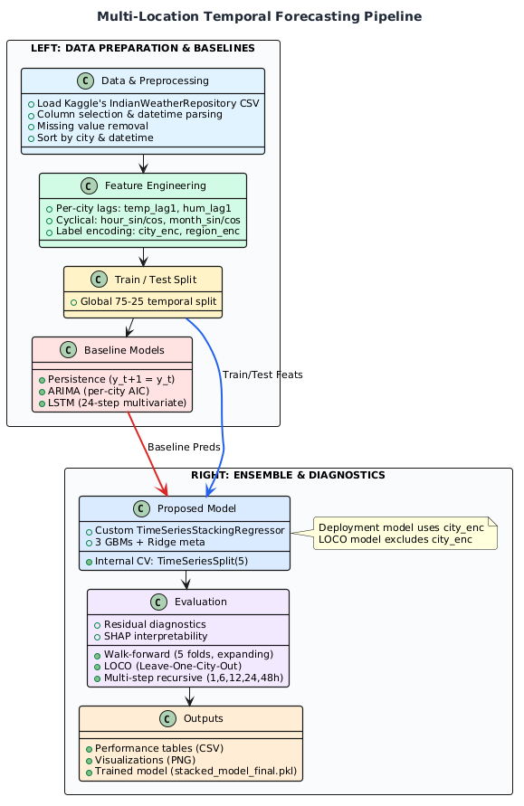
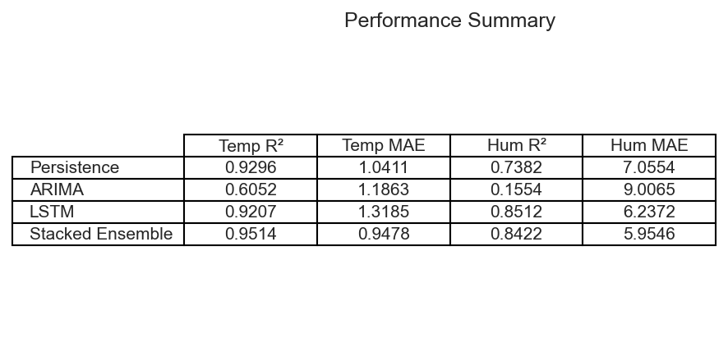
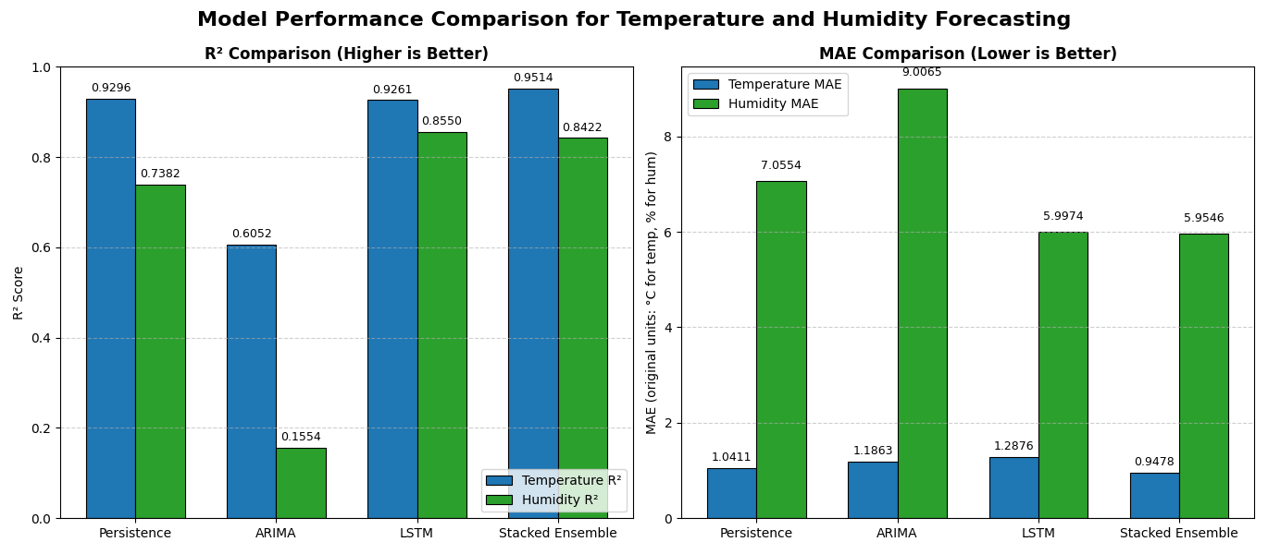

OR

